Lecture Workshop I & II: Puzzles and Thinking Outside the Box

Appendix A
Lecture 1: Quiz

- What is the lecturer’s responsibility?

- What is the student’s responsibility?

- Why do we take notes?

- How can we take notes?

- How many triangles are there?


SCORE: /11
2 points = Score 11 ~ 7 | 1 point = Score 6 ~ 1 | 0 points = Score 0

Appendix B
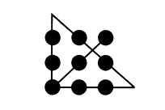 | 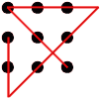

Answers. Can you draw 4 straight lines through the 9 dots?

Appendix C
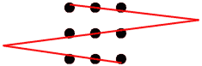

Answer. Can you draw 3 straight lines through the 9 dots?

Appendix D
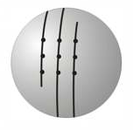

Answer. Can you draw 1 continuous lines through the 9 dots? (Think three dimensionally)

