AWE: Basic Formal E-mails

Writing and reading skills:
Using genre-based knowledge for the situation and structure of formal e-mails.

Discussion skills:
Sharing ideas in pairs, a group, and reporting.

Pre-tasks:
Discuss the following with a partner:
- What does e-mail mean?
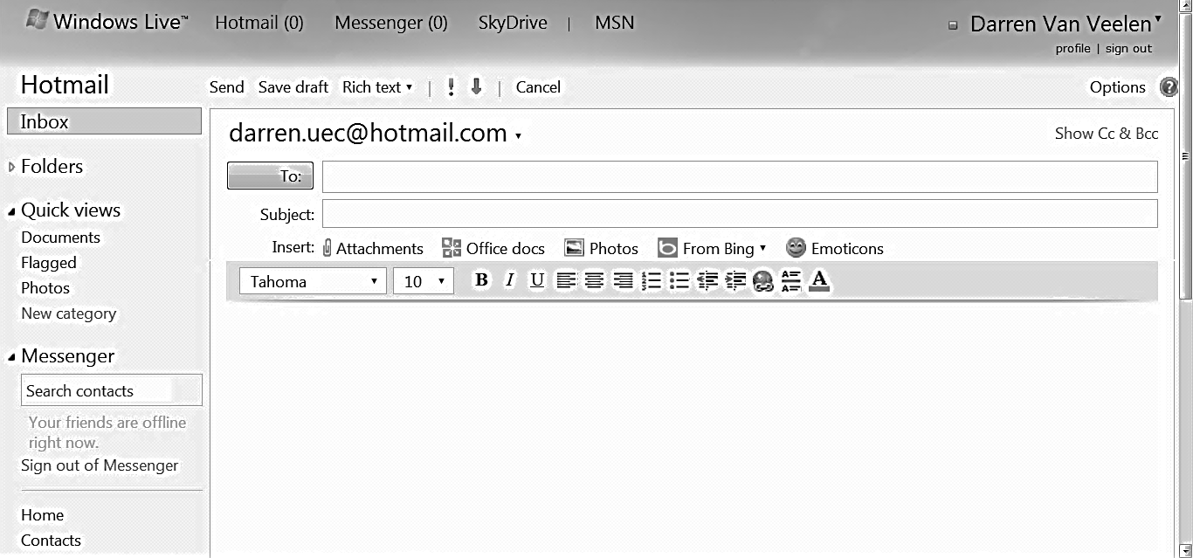
- Look at the picture of a blank email below.
What do these features mean?
To:
Cc
Bcc
Subject
Attachments
Save draft

- List some differences between casual and formal emails.

Model:
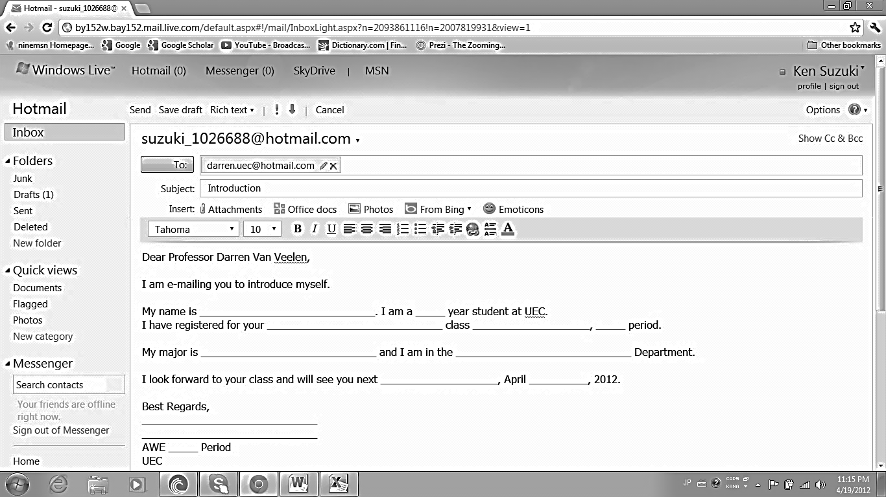
- Formal e-mail: Below is the correct format of a formal e-mail to introduce yourself to the teacher.

- In the picture above, write the numbers of the generic moves/stages.
1 | Link or reason
2 | Closing
3 | Expression of information
4 | Opening

AWE: Scientific Definitions & Product Specifications (Lesson 1)

Writing and reading skills:
Using genre-based knowledge for the situation and structure of scientific terms and definitions.

Discussion skills:
Sharing ideas in pairs, a group, and reporting.

Pre-tasks:
- Read ‘Remembering scientific terms’. Make a list of terms specific to your area of study. Can you identify the prefix, stem, and/or suffix?
http://www.unit5.org/villhauer/Resources/prefixes_roots_and_suffixes.htm
Term | Prefix | Stem | Suffix
Biology | Bio  life |  | logy  study of
Cell |  | Cell  basic structural unit

- When reading, you should be critically thinking about text so as to evaluate if it is reliable or unreliable. Answer the situation questions:
  - What is a scientific definition? OR What is the purpose of a scientific definition?
  - Who writes scientific definitions?
  - Who reads scientific definitions?
  - Where can you find scientific definitions?
AWE: Scientific Definitions & Product Specifications (Lesson 2)

Model:
- The text type ‘scientific definition’ usually has a predictable schematic structure or moves:
Term | Class | Characteristics
A university is | an institution | where knowledge is “produced” and passed on to others.
Water is | a liquid | made up of molecules of hydrogen and oxygen in the ratio of 2 to 1.
Astronomy is | a branch of scientific study | primarily concerned with celestial objects inside and outside the earth’s atmosphere.
Research may be defined as | a systematic process | which consists of three elements or components: (1) a question, problem, or hypothesis, (2) data, and (3) analysis and interpretation of the data.

Together:
- Try and write your own definitions for the following.
Term | Class | Characteristics
Classic gaming

Comic books

Engineering

Biology

You:
- Write definitions for 3 terms that are specific to your area of study.
Term | Class | Characteristics

AWE: Scientific Definitions & Product Specifications (Lesson 3)

Writing and reading skills:
Using genre-based knowledge for the situation and structure of product specifications.

Discussion skills:
Sharing ideas in pairs, a group, and reporting

Pre-tasks:
- Read the product specification at http://www.apple.com/ipad/specs/

- When reading, you should be critically thinking about text, so as to evaluate if it is reliable or unreliable. Answer the situation questions:
- What is a product specification? OR What is the purpose of a product specification?
- Who writes product specifications?
- Who reads product specifications?
- Where can you find product specifications?

- Read the guide to writing specifications.

A specification should be:
- Simple but exact
- Identified with technical terms
- Reasonable in its tolerances (unnecessary precision is expensive and restrictive)
- Clear and understandable

Model:
- Read the product specification below. Make corrections to improve it.

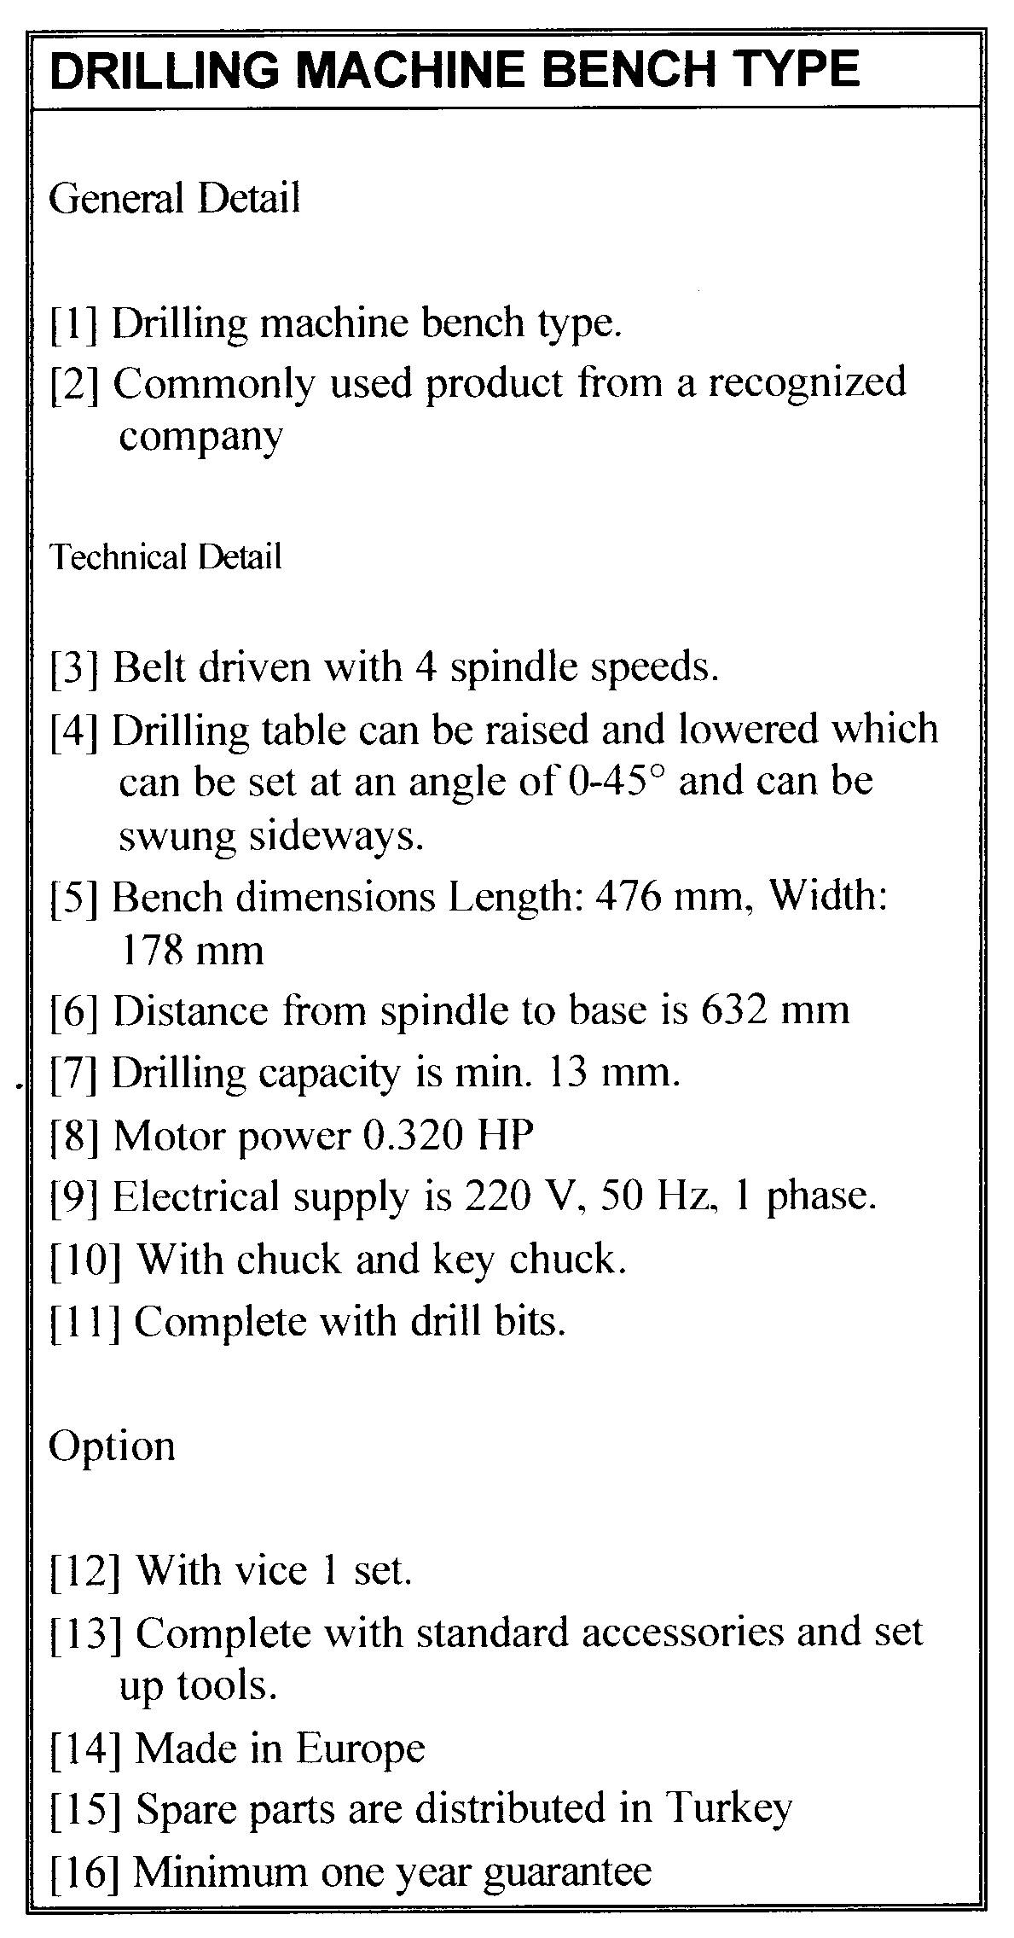

AWE: Scientific Definitions & Product Specifications (Lesson 4)

You:
The iPad: Technical Specifications Revision
- Look at the technical specifications for iPad at http://www.apple.com/ipad/specs/
- Answer the questions.
- For the dimensions of the iPad (i.e., look at the pictures), why are inches (e.g., 7.31”) not the best unit of measurement for specifications?
- In Size and Weight, why is the Height not (241.2683 mm)?
- In Input and Output, what is wrong with writing the following specification? Rewrite it.
I think the built-in speaker is the best speaker in the world for listening to Rock music and playing lots of Rock music in the park with my friends.
- In Location, what is wrong with writing the following specification? Rewrite it.
The kind of thing that you do when you want to connect to information from around the world with no cable to your PC.
- In Cameras, Photos, and Video Recording, how could you rewrite the following to make it simpler for Japanese consumers?
Photo and video geotagging
- Send your answers to Darren by e-mail to get 1% for homework.

Together & You:
Product Specifications Assessment (5%)
- Choose a product.
- Answer the questions for Checklist 1 – Getting Started.
- Write 5 specifications for your product and use the correct format.
- Use the technical specifications models for the iPad at http://www.apple.com/ipad/specs/ and the Drilling Machine Bench Type to help you.
- Send your Checklist 1 – Getting Started answers & 5 product specifications to Darren by e-mail.

