AWE: Basic Formal E-mails

Writing and reading skills:
Using genre-based knowledge for the situation and structure of formal e-mails.

Discussion skills:
Sharing ideas in pairs, a group, and reporting.

Pre-tasks:
Discuss the following with a partner:
- What does e-mail mean?
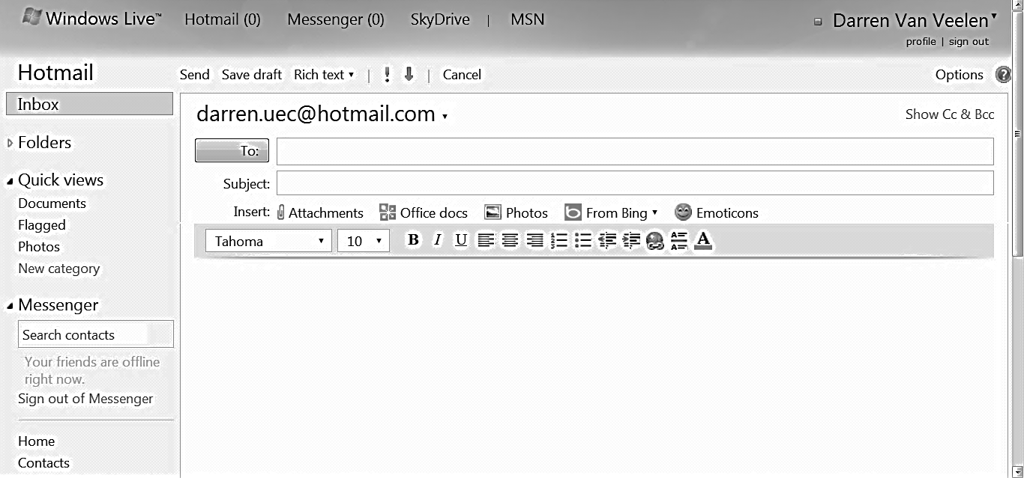
- Look at the picture of a blank email below.
What do these features mean?
To:
Cc
Bcc
Subject
Attachments
Save draft

- List some differences between casual and formal emails.

Model:
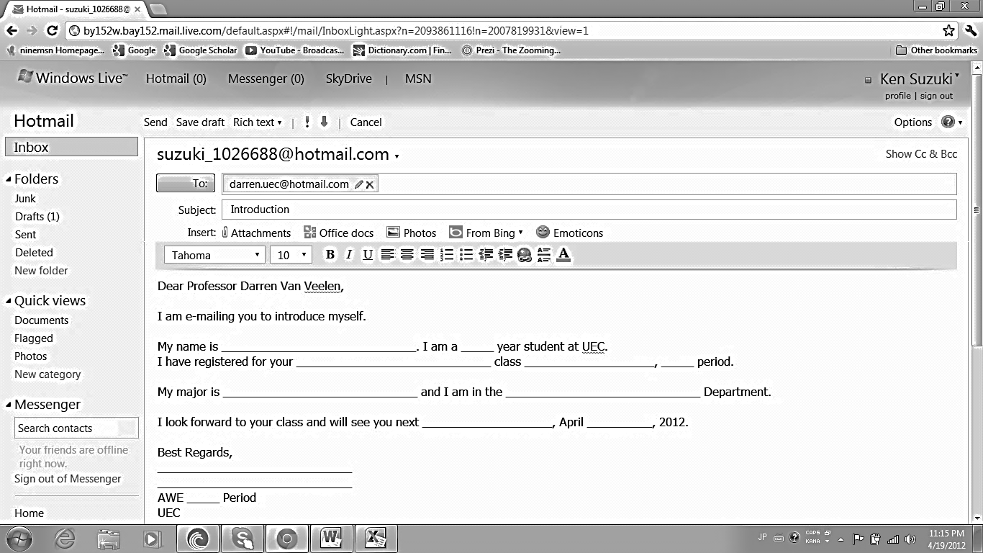
- Formal e-mail: Below is the correct format of a formal e-mail to introduce yourself to the teacher.

- In the picture above, write the numbers of the schematic stages.
1 | Link or reason
2 | Closing
3 | Expression of information
4 | Opening

AWE: Scientific Definitions & Product Specifications (Lesson 1)

Writing and reading skills:
Using genre-based knowledge for the situation and structure of scientific terms and definitions.

Discussion skills:
Sharing ideas in pairs, a group, and reporting.

Pre-tasks:
- Read ‘Remembering scientific terms’. Make a list of terms specific to your area of study. Can you identify the prefix, stem, and/or suffix?
http://www.unit5.org/villhauer/Resources/prefixes_roots_and_suffixes.htm
Term | Prefix | Stem | Suffix
Biology | Bio  life |  | logy  study of
Cell |  | Cell  basic structural unit

- When reading, you should be critically thinking about text so as to evaluate if it is reliable or unreliable. Answer the situation questions:
  - What is a scientific definition? OR What is the purpose of a scientific definition?
  - Who writes scientific definitions?
  - Who reads scientific definitions?
  - Where can you find scientific definitions?
AWE: Scientific Definitions & Product Specifications (Lesson 2)

Model:
- The text type ‘scientific definition’ usually has a predictable schematic structure or moves:
Term | Class | Characteristics
A university is | an institution | where knowledge is “produced” and passed on to others.
Water is | a liquid | made up of molecules of hydrogen and oxygen in the ratio of 2 to 1.
Astronomy is | a branch of scientific study | primarily concerned with celestial objects inside and outside the earth’s atmosphere.
Research may be defined as | a systematic process | which consists of three elements or components: (1) a question, problem, or hypothesis, (2) data, and (3) analysis and interpretation of the data.

Together:
- Try and write your own definitions for the following.
Term | Class | Characteristics
Classic gaming

Comic books

Engineering

Biology

You:
- Write definitions for 3 terms that are specific to your area of study.
Term | Class | Characteristics

